Factors Contributing to Large Flow Fluctuations on the Poudre River Near Fort Collins  by  John Bartholow |  | Though we do not fully understand the impacts on the Poudre, negative or positive, abrupt flow fluctuations are closely associated with higher energetic costs, lower growth rates, and reduced spawning and rearing success for many fish species. |  | Findings  Most large, abrupt fluctuations were either explainable due to routine opening and closing of diversions above and below the Lincoln Gage, or not explainable given unavailability of data. But two other situations were more unexpected: |  | Management Opportunities  and Data Needs  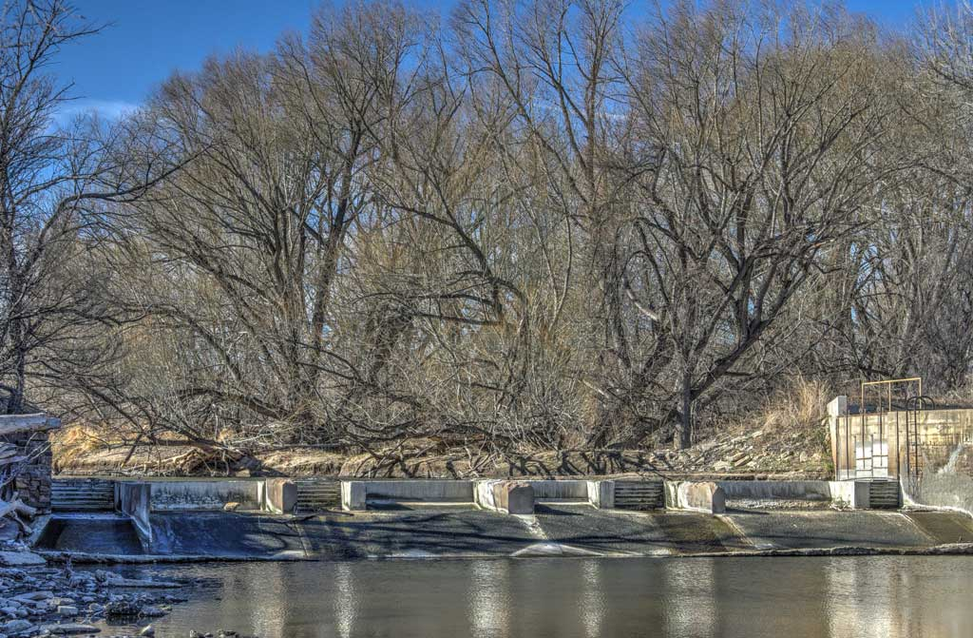
Abstract  We investigated the reasons why there are often large, rapid flow fluctuations on the Poudre, why they may be important for the river and some users, and what might be done to lessen their likely impact. |  | For example, abrupt flow spikes can disrupt brown trout spawning in October. | 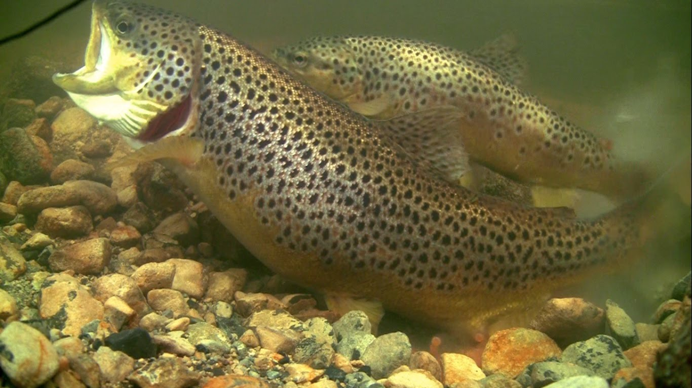  From YouTube | Sometimes routine maintenance can suddenly shut down an ongoing diversion and result in a spike in downstream flow. | 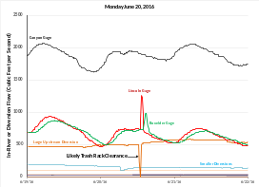 | There are operational opportunities to mitigate at least some abrupt fluctuations, including tweaking ramping rate guidelines and exploring changes with existing or potentially new diversions.  There are also structural opportunities including automation of diversion headgates and trash rack modifications, as well as adding fish passage facilities that would help buffer flow fluctuations.  2016 may have been an unusually subdued year for abrupt fluctuations. More years of more data on more diversions, especially large ones, may reveal other opportunities to improve the flow regime, especially for warm water fish and public safety.  Many Thanks To:  Scott Hummer, Ken Kehmeier, Bob Milhous, Steve Malers, Andy Pineda, Luke Shawcross, Jen Shanahan, Mark Simpson, Kristin Swaim, Reagan Waskom, and Brad Wind for professional help and advice.    For More Information, please contact John.M.Bartholow@Gmail.com
Problem  Gaging records reveal spikes or plunges that are large, brief, and not always easy to explain. This investigation was meant to explore the reasons and brainstorm potential remidies. | 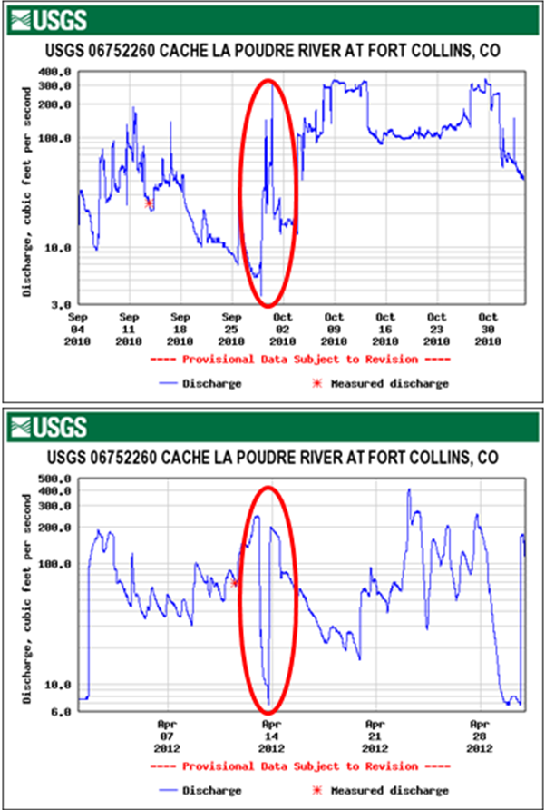 | Abrupt flow fluctuations can affect the quality and safety of river-based recreation. The public cannot anticipate sudden flow changes. Flows that are safe for a young child for tubing at 10 am could be unsafe by noon.   |  | 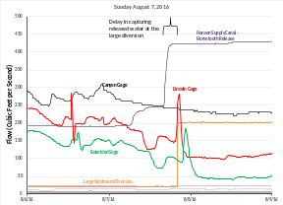 | Other times, there can be a delay in the “capture” of water released for a specific diversion, resulting in a downstream spike. If the capture had preceded the arrival of released water, there would have been a plunge.
Abrupt flow fluctuations can dewater channels (especially side channels) leading to fish stranding, especially when gradients are low and substrates (e.g., cobbles) are large.  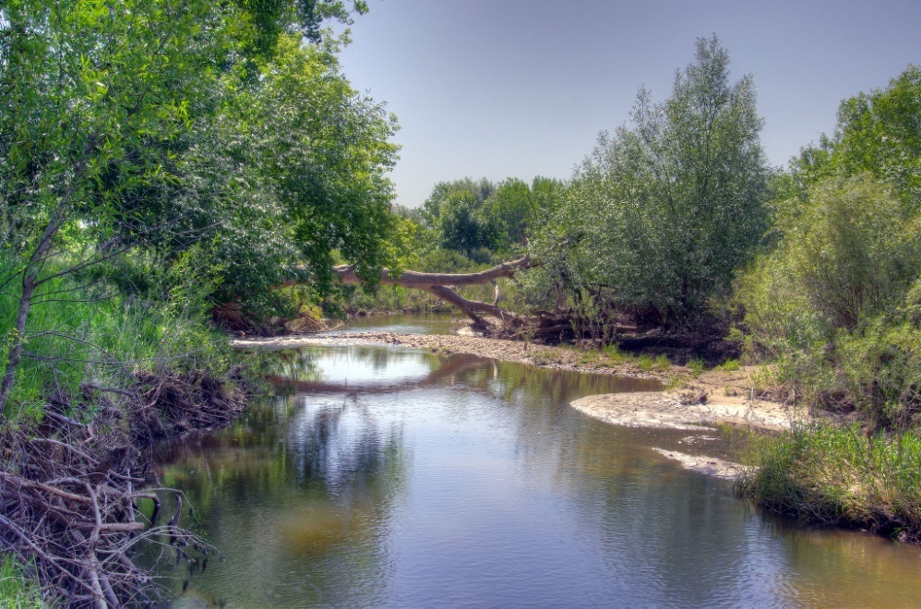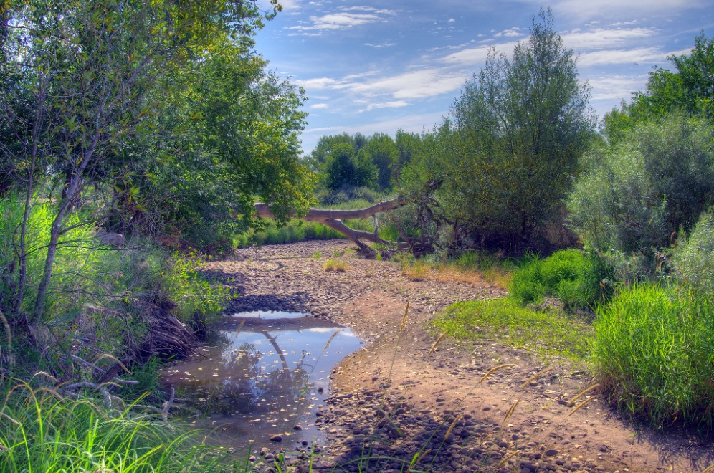 |  | Methods  We used 15-minute data for 2016 from the Canyon Gage to the Boxelder Gage. Map shows water imports and withdrawals, green arrows were available data, yellow were unavailable.  [Insert simple map with colored arrows into and out of river, major roads, labeled gages but not labeled diversions. Also show Horsetooth Reservoir and Hansen Canal. “Map” could be just a line.] |  | In addition, there are often abrupt changes in the delivery of water from Horsetooth, frequently ramping down for weekends and ramping back up on weekdays.  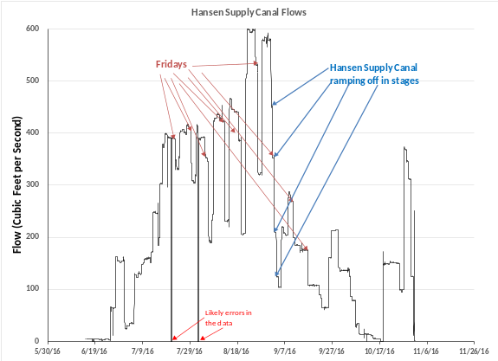

Notes:

1. See about a better photo of a Poudre River diversion structure.

2. Clip art is just from Word.

