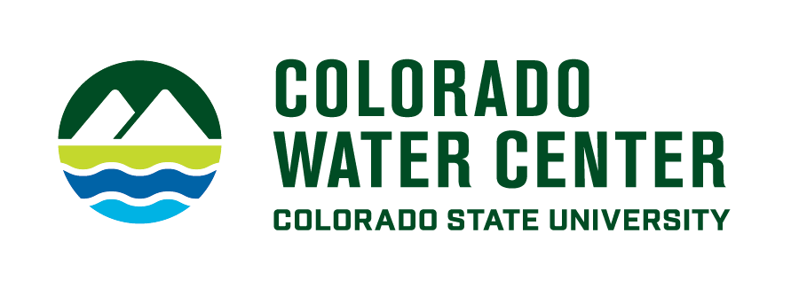
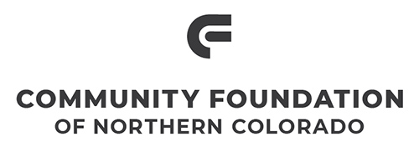

Water Literate Leaders of Northern Colorado

September 14, 2022 | Speaker Biographies

PATRICIA “PATTY” RETTIG | Head Archivist, Water Resources Archive, Colorado State University
Patty Rettig is the archivist for the Water Resources Archive at the Colorado State University Libraries.

Rettig has built the archive to hold over 130 distinct collections documenting Colorado’s water heritage by engaging with the water community across the state. This involves working with people throughout the university as well as with state and federal agencies, ditch companies, businesses, and individuals.

She earned her Master of Library Science from the University of Maryland, College Park, and her B.A. in English from Wittenberg University. She has been with the Water Resources Archive since its beginning in 2001. She received the Friends of the South Platte Award in 2014.

ZANE KESSLER | Director of Government Relations, Colorado River District
Zane Kessler is the Director of Government Relations at the Colorado River District. In this role, Zane manages the District’s state and federal policy efforts and coordinates the organization’s work with partners, municipalities and counties on West Slope policy matters.

MARTÍN CARCASSON | Professor, Colorado State University
Martín Carcasson, Ph.D., is a professor in the Communication Studies department of Colorado State University, the founder and director of the CSU Center for Public Deliberation (CPD), and a faculty member for CSU’s newly minted Masters in Public Policy and Administration program. His research focuses on helping local communities address “wicked problems” more productively through improved public communication, community problem solving, and collaborative decision-making. The CPD is a practical, applied extension of his work, and functions as an impartial resource dedicated to enhancing local democracy in Northern Colorado. Dr. Carcasson and the CPD staff train students to serve as impartial facilitators, who then work with local governments, school boards, and community organizations to design, facilitate, and report on innovative projects and events on key community issues. In the fall of 2021, he helped launch the Northern Colorado Deliberative Journalism Project, and continues to serve on the core team for the project.

