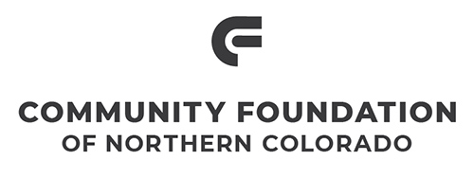
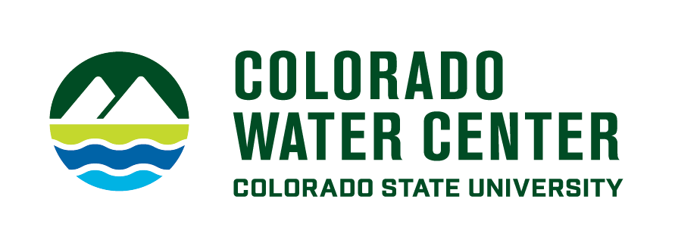

Water Literate Leaders of Northern Colorado

February 15, 2023 | Speaker Biographies

WADE WILLIS | Open Space & Trails Manager, Town of Windsor
Wade Willis is the Open Space and Trails Manager for the Town of Windsor. Wade grew up in Windsor, is a CSU graduate, and has worked for the Town for over 20 years. Wade was around 11 years old when he remembers seeing an article in the Greeley Tribune “Poudre Trail to Connect Fort Collins to Greeley.” As an avid bicyclist, he was incredibly excited. Wade is involved in many Poudre River efforts including serving as the Chair of the Poudre Heritage Alliance Board of Directors, a participant in the Poudre Runs Through It Study/Action Work Group, and the Coalition for the Poudre River Watershed. Wade met his wife leading a volunteer effort on the Poudre Trail near the Poudre Learning Center.

JUSTIN SCHARTON | Natural Areas and Trails Division Manager, City of Greeley
Justin Scharton is a Dedicated natural resource professional with eclectic professional experience and a strong skillset in a variety of environmental and natural resource management topics including open space, water rights, volunteer management, research, wildlife management, GIS and urban nature integration. Justin leads the Natural Areas & Trails team for the City of Greeley, with primary roles including strategic planning, team oversight and culture-building, budget planning and funding development, land conservation efforts, policy and enforcement, capital project development and oversight, community engagement, and advocating and planning for division growth.

BRAD MODESITT | Owner, Mountain Whitewater & Paddler’s Pub
In 1993, Brad Modesitt and his brother Kent canoed down the Poudre, Platte, Missouri, and Mississippi Rivers to end up 2400 miles later in New Orleans. This experience left both of them with a deep respect for our nation’s rivers. Kent started law school and is now an attorney in Denver. Brad continued his journey and the traveling lifestyle bicycling 10,000 miles and sailing 3000 miles to southern Chile. When he returned a friend told him he should become a rafting guide. It was good advice. Brad still guides rafts down the river he loves, enjoying the people, the scenery, and of course the rapids.
GREG KERNOHAN | Director of Conservation Programs, Ducks Unlimited
Greg Kernohan was born and raised in Ontario Canada and now lives in Fort Collins with his wife Niki and two daughters, Devyn and Meghan. Greg directs Ducks Unlimited’s environmental market programs for the Great Plains Region including supervision of the world’s only certified grassland carbon offset trading, wetland mitigation, and water augmentation programs. Having spent over 20 years with Ducks Unlimited, Greg has developed a breadth of experience in waterfowl research, wetland ecology, habitat management, conservation strategies, ecosystem market development, and environmental policy. Greg attended Sir Sandford Fleming College in Canada where he earned a degree in Terrain and Water Resources and then completed a Bachelor of Science in Environmental Science at Oregon State University. Greg most recently graduated summa cum laude with a master’s degree in environmental law and policy at Vermont Law School.

ERIK ANGLUND | Rockies Water Team Manager, Occidental Petroleum
Erik Anglund is a native Colorado farm kid and is the Rockies Water Team Manager for Occidental Petroleum. He works on all things water-related for the company’s operations in the Rockies including activities for construction, drilling, hydraulic fracturing, production, disposal, and recycling.
He has spent his career working with agricultural, municipal, and industrial water rights, regulations, permitting, and projects in Colorado and Wyoming. Erik also serves on the board of the Colorado Water Congress and the South Platte Water Related Activities Program. He has degrees in Mechanical Engineering, Agricultural Engineering, and Organizational Leadership; and is a registered Professional Engineer in Colorado, Wyoming, and Utah.”

BILL RITTER | Former Colorado Governor, Founder and Director of the Center for the New Energy Economy at Colorado State University
Bill Ritter, Jr. is the founder and director of the Center for the New Energy Economy (CNEE) at Colorado State University, which launched on February 1, 2011.

Governor Bill Ritter was elected Colorado’s 41st Governor in 2006 and was the District Attorney of Denver from 1993-2005. During his four-year term as Governor, Ritter established Colorado as a national and international leader in clean energy by building a New Energy Economy. After leaving the Governor’s Office, Ritter founded the Center for the New Energy Economy at Colorado State University, which works with state and federal policymakers to create clean energy policy throughout the country. Governor Ritter authored a book that was published in 2016 entitled, Powering Forward – What Everyone Should Know About America’s Energy Revolution.

Governor Ritter is the current Board of Directors chair for The Climate Group North America and former chair of the Board of Directors of the Energy Foundation and currently serves on the Board of Trustees of The Nature Conservancy. Ritter is a member of Blackhorn Venture Capital and serves as an advisor to Green Alpha and Project Canary, among others. Ritter earned his bachelor’s degree in political science from Colorado State University (1978) and his law degree from the University of Colorado (1981). With his wife Jeannie, he operated a food distribution and nutrition center in Zambia.

